Tests
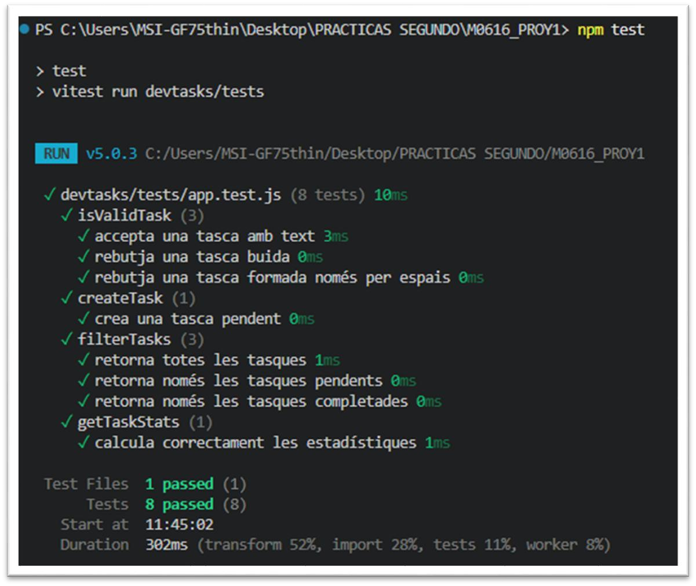
- TasksManager
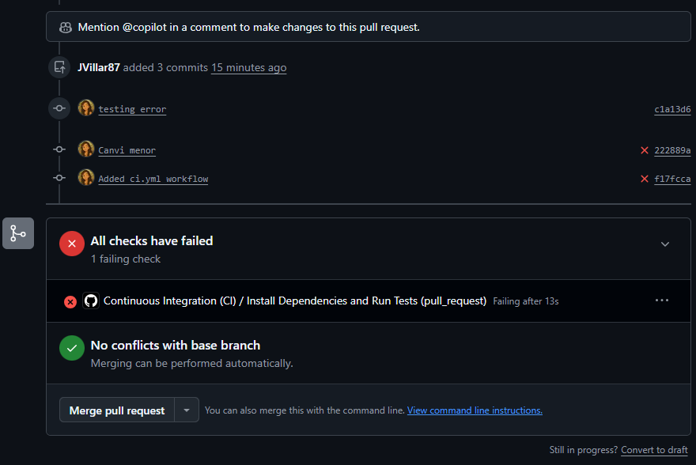
- CI.yml (test failed)
- CI.yml (test passed)

